ASAM CONTINUUM® Implementation

Frequently Asked Questions

ASAM CONTINUUM® Overview 3
1. What is ASAM CONTINUUM® – The ASAM Criteria Decision Engine? 3
2. What is the difference between the ASAM Criteria® and ASAM CONTINUUM®? 3
3. What does the CONTINUUM® Narrative Report include? 3
4. What does the CONTINUUM® Assessment Summary Report include? 3
5. How long does it take to conduct the CONTINUUM® assessment? 4
6. How does CONTINUUM® address an SUD client with a mental health diagnosis? 4
7. *NEW- Will the CONTINUUM® replace the GAIN I-Core? 4
Who Can Administer CONTINUUM®? 5
8. *NEW- Is a Master level clinician required to conduct the assessment? 5
When, How, and with Whom to Conduct a CONTINUUM® Assessment 5
9. *NEW- How often should I complete the ASAM CONTINUUM® with a consumer? 5
10. *NEW- What should a provider do if an ASAM CONTINUUM® was completed with a previous provider but attempts at obtaining the assessment from that provider have been unsuccessful? 5
11. How do I begin an ASAM CONTINUUM® assessment? 6
12. How do I access ASAM CONTINUUM® in the MSHN REMI system? 6
13. Can the ASAM CONTINUUM® be used to assess adolescents? 6
14. *NEW- With which clients am I required to conduct the ASAM CONTINUUM® assessment? 6
CONTINUUM® Administration Tips and Nuances 6
15. Can I see a preliminary DSM SUD Diagnosis or Level of Care recommendation prior to completing and submitting the assessment? 6
16. If a consumer’s response to a question in the psychological section triggers more questions/exploration for the clinician how should this be handled? 7
17. *NEW- If a clinician notices an error on a completed and submitted ASAM CONTINUUM® assessment, is it possible to make a correction? 7
18. If a clinician initiates an ASAM CONTINUUM® assessment but does not complete the assessment can anyone else who has access to that client record log into that same assessment and continue, edit, etc.? 7
19. *NEW- ASAM CONTINUUM® recommends a different level of care (LOC) than what the person is willing to engage in; How do I document this occurrence? 7
20. *NEW - How to address when ASAM CONTINUUM® recommends withdrawal management for individuals requesting Medication Assisted Treatment in an outpatient setting? 9
Finalizing the Assessment, Signatures, and Reports 9
21. How can my supervisor sign-off on my completed CONTINUUM® assessment? 9
22. Who will have access to the completed assessment? 9
23. Can I integrate ASAM CONTINUUM® with my agency’s EHR/EMR? 9
24. What report should I upload to REMI to meet the assessment requirement of authorizations/re-authorizations? 9
Billing and Processing 9
25. *NEW- What code do I use for billing a CONTINUUM® Assessment? What code should I use for billing a partial or incomplete CONTINUUM® Assessment? 9
26. How do I submit for training time reimbursement? 10
27. *NEW- How should providers bill for an ASAM CONTINUUM® Update? 10
28. *NEW- If more than one session is needed to complete the ASAM CONTINUUM®, how does the provider bill for this occurrence? 10
Other 10
29. *NEW- Is there an accreditation crosswalk to compare JACHO and/or CARF standards to ASAM CONTINUUM®? 10
CONTINUUM® Training and Certification 11
30. How can I be trained to use ASAM CONTINUUM®? 11
Technical Support 12
31. Who can I contact for support? 12

ASAM CONTINUUM® Overview

What is ASAM CONTINUUM® – The ASAM Criteria Decision Engine?
ASAM CONTINUUM® provides counselors, clinicians and other treatment team members with a computer-guided, structured interview for assessing patients with addictive, substance-related conditions and to inform treatment planning. The decision engine is based on The ASAM Criteria® and uses research-quality questions (including tools such as the ASI, CIWA, and CINA instruments) to generate a comprehensive patient report, that details DSM substance use disorder diagnoses, severity and imminent risks as well as a recommended treatment level of care determination.

Note: At this time only ASAM CONTINUUM® will be implemented. There are no plans to utilize ASAM Co-Triage® as a brief screener tool.

What is the difference between the ASAM Criteria® and ASAM CONTINUUM®?
The ASAM Criteria® is the most widely used and comprehensive text of guidelines for treating patients with substance use disorder. ASAM CONTINUUM® is a software which guides clinicians through an ASAM Criteria assessment and assists them with determining appropriate level of care placement. ASAM CONTINUUM® and The ASAM Criteria should be used in tandem—the text provides background and guidance for proper use of the software, and the software enables comprehensive, standardized evaluation. With CONTINUUM®, clinicians can easily conduct a comprehensive biopsychosocial patient risk and needs assessment along all six ASAM Criteria Dimensions while determining the ASAM Criteria Levels of Care recommendation.

What does the CONTINUUM® Narrative Report include?
The ASAM CONTINUUM® Narrative Report contains an automated narrative summary of the patient’s condition, derived from selected structured interview items and a clinical consensus algorithm. Directions regarding how to download and save this report are included in the ASAM CONTINUUM® Interface User Manual. You may also download copies of the reports to your computer.

The Narrative Report is a chart-ready, multi-page report that includes the following information:

- The Cover Page – includes the patient’s ID number, name, and the date and time the assessment began and ended.
- Medical, Employment, Alcohol and Drug, Family and Social, Psychiatric Sections – provide a narrative of the patient’s history, current presentation, and perception of problems and treatment need compared to the clinician’s perception.
- Patient Perception Rating Graphics – compare the patient’s rating of problems to the patient’s rating of desire of treatment.
- Addiction Severity Index Composite Scores – a graphical and numerical summary of the seven categories rated by addiction severity index including Medical, Alcohol, Drug Psychological, Employment, Family, Social and Legal.
- ASAM CONTINUUM® Problem List – breaks down the patient’s treatment needs by the six ASAM Criteria Dimension and helps inform the treatment plan.
- Please note that this report does not replace individual provider’s clinical judgment.

What does the CONTINUUM® Assessment Summary Report include?
The ASAM CONTINUUM® Assessment Summary Report contains an analysis and placement recommendations based on the scored questionnaire items. Directions regarding how to download and save this report are included in the ASAM CONTINUUM® Interface User Manual. You may also download copies of the reports to your computer.

The Summary Report is an individualized, multi-page report that includes the following information:

- The cover page – which includes the patient’s ID number, name, and the date and time the assessment began and ended.
- Diagnostic Suggestions – provides possible non-substance use and psychological conditions.
- DSM-5 Diagnosis – including current substance use disorder(s), criteria count and severity rating.
- Withdrawal Scales – the final scores of the patient’s levels of withdrawal complications.
- Addiction Severity Index Composite Scores –the severity of addiction in seven areas of the patient’s life including Medical, Alcohol, Drug Psychological, Employment Family, Social and Legal.
- Critical Items – serious concerns about safety, and steps that should be considered.
- Dimensional Analysis – describes the Levels of Care criteria that each dimension fits.
- Access to Treatment Issues – provides information related to transportation, mobility, and compliance with treatment attendance.
- Final Level(s) of Recommendation – the best recommendation(s) that can be determined by the ASAM algorithm (unless no level of care can be precisely calculated).
- Please note that this report does not replace individual provider or sound clinical judgment.

How long does it take to conduct the CONTINUUM® assessment?
This always depends on the patient’s use history as well as other factors, after training and a learning curve of 15-20 cases, the ASAM CONTINUUM® assessment was independently found to take the average clinician about 60 minutes to complete. The first time an assessment is completed, it might take two hours as users begin to navigate the tool. The assessment is designed to be easily broken up into separate sessions. Training is important for improving efficiency. MSHN recommends that providers take this information into consideration and structure intake/assessment appointments for longer periods of time to account for longer duration on the front end until time on the ASAM CONTINUUM® assessment decreases over time.

How does CONTINUUM® address an SUD client with a mental health diagnosis?
With CONTINUUM®, while a DSM mental health diagnosis is not automated, clinicians can easily evaluate patients with co-occurring substance use disorder and mental health conditions. The assessment helps clinicians by assessing psychiatric syndrome areas, distinguishing each symptom’s perceived relationship to substance use, and assessing key components related to suicidality. Additional assessment may be necessary, but not required at this time, for a patient presenting with co-occurring symptoms.

*NEW- Will the CONTINUUM® replace the GAIN I-Core?
CONTINUUM® has been selected as the sole SUD Assessment tool for adult consumers. This is the required biopsychosocial assessment for adults. The ASAM CONTINUUM® is not validated for adolescents, therefore the GAIN I-Core has been selected by MDHHS as the biopsychosocial assessment for adolescents after 10-1-2021.

Who Can Administer CONTINUUM®?

*NEW- Is a Master level clinician required to conduct the assessment?
Per guidance from MDHHS (3-26-2021), through consultation of LARA with the Bureau of Professional Licensing, as long as a person has an appropriate MCBAP credential to support assessments per LARA SUD Administrative Rule guidelines, then they are able to complete the ASAM CONTINUUM®. The provider would need to continue to have the assessments reviewed and signed off on by a master’s level and licensed clinician.

It is possible that an intern who is able to meet the qualifications to obtain a CADC (or CADC-development plan), is able to support the ASAM CONTINUUM® with appropriate supervision and oversight by a master’s level and licensed clinician. (See image a. below.) To clarify, a MCBAP credential is not required, only the education and qualifications that would support a development plan are required.

- MDHHS Guidance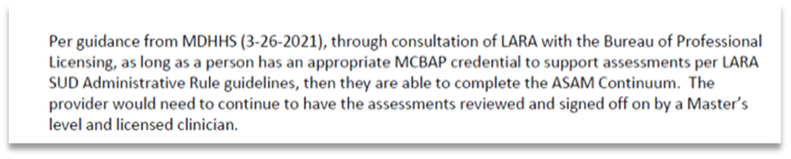

When, How, and with Whom to Conduct a CONTINUUM® Assessment

*NEW- How often should I complete the ASAM CONTINUUM® with a consumer?
The assessment must be administered at least annually. Depending on the needs of the person, the clinician can determine if a new ASAM CONTINUUM® is warranted or if an update to the ASAM CONTINUUM® will be sufficient to guide treatment. Per MDHHS requirement, MSHN will only support reimbursement of a maximum of four new assessments (H0001) per year per beneficiary in the SUD provider system. Collaboration of care is essential to ensure that assessments are being shared (with consent), and persons served do not have to repeat the assessment process unnecessarily. MSHN may deny payment if it is determined that a new ASAM CONTINUUM® was performed when it was not clinically necessary or without appropriate attempts to obtain prior assessments.

If an assessment update is completed, the provider should utilize an individual therapy session code (i.e. 90832, 90834, 90837, or H0004) instead of the H0001 code. As the ASAM CONTINUUM® has an “update” function which copies forward the previous assessment information, much less time will be needed to update an assessment than completing an initial assessment. Also, MDHHS will only support reimbursement of four assessments per year, per beneficiary in the SUD provider system. The use of the individual therapy code for assessment updates, will assist with preserving the H0001 encounters for future use, as needed.

*NEW- What should a provider do if an ASAM CONTINUUM® was completed with a previous provider but attempts at obtaining the assessment from that provider have been unsuccessful?
MSHN encourages and supports ALL of our SUD Treatment providers to coordinate care for individuals being transferred within the provider network. This includes providing supports with warm hand-offs between levels of care from the sending to receiving provider. If an assessment was completed at the initial level of care for a person entering services, that ASAM CONTINUUM® assessment should be provided to the persons choice of next level of care provider on their pathway to recovery, with appropriate consent in place.

If a provider has attempted to obtain the ASAM CONTINUUM® from the previous provider on at least 3 occasions without success, then MSHN would recommend contacting your agency treatment specialist for assistance. In instances where the delay in receiving an assessment may impact the person’s ability to engage in services, then MSHN recommends proceeding with completing a new ASAM CONTINUUM® assessment. Please note, that with the length of time needed to complete an assessment like ASAM CONTINUUM® and requiring individuals to complete them at multiple steps in an episode of care could impact the persons willingness to engage in services in the future.

How do I begin an ASAM CONTINUUM® assessment?
Once you have logged into REMI, you can access “How-to-Guides” and “User Manuals” by selecting the (? Help) link on any REMI page. If you do not have a REMI user account, contact your supervisor.

How do I access ASAM CONTINUUM® in the MSHN REMI system?
The agency’s clinical supervisor can contact their lead treatment specialist and request access to ASAM CONTINUUM® for staff who have been trained and meet appropriate qualifications and credentials to support the ASAM CONTINUUM®. Before requesting access from MSHN, the clinical supervisor should ensure the staff person has an active account in REMI and is designated as a “provider clinician.” Once this has been verified, the clinical supervisor can send the person’s name, qualifications/credentials, active email, and ASAM CONTINUUM® Certificate of Completion to the treatment specialist to request access.

Can the ASAM CONTINUUM® be used to assess adolescents?
ASAM CONTINUUM® is NOT for use with the adolescent population, those under 18 years of age. The tool is not validated for use with adolescents and the diagnosis and report summary may not be accurate. Instead, clinicians who conduct adolescent SUD assessments must use the GAIN I-Core from October 1, 2021, and until further notice.

*NEW- With which clients am I required to conduct the ASAM CONTINUUM® assessment?
ASAM CONTINUUM® has been selected as the sole SUD Assessment tool for adults and is required by all providers serving clients whose services are funded through Medicaid, Healthy Michigan, and/or Block Grant as of October 1, 2021. As stated previously, the GAIN I-Core is the required assessment tool for adolescents as of October 1, 2021.

CONTINUUM® Administration Tips and Nuances

Can I see a preliminary DSM SUD Diagnosis or Level of Care recommendation prior to completing and submitting the assessment?
Presently, the interviewer is not able to see the SUD Diagnostic Findings before submitting the interview. While this is being considered by the ASAM Science Team as a possible future modification, interviewers should remember that questions in the Drug and Alcohol section with an item code beginning with “CUA” correspond to the DSM criteria for substance use. A “Yes” response to these items will generate the DSM criteria met in the Diagnostic Findings section. This is to support the clinician in determining whether a mild, moderate, or severe substance use disorder is present. Interviewers should use the same follow up questions and discernment within this block of questions as they would with any other SUD diagnostic assessments.

Interviewers are unable to preview the LOC recommendations prior to submitting the assessment. However, they can provide their recommendation for appropriate levels of care along with the patient’s preferences before submitting the assessment. The algorithm does consider these recommendations in its final output. The Review Section, which becomes available after the assessment is submitted, allows the interviewer to record the final disposition and comments contextualizing any disagreement.

If a consumer’s response to a question in the psychological section triggers more questions/exploration for the clinician how should this be handled?
ASAM has not developed specific guidance around administering the psychological section. CONTINUUM® is used in a variety of varying settings with differing assessment protocols. Guidance for this section is more appropriately developed by the agency’s supervising entities as they have an in depth understanding of their specific landscape.

We do advise that CONTINUUM® be administered within the same parameters as other clinical intakes. It can be helpful for the interviewer to establish that CONTINUUM® is an assessment designed to evaluate where the patient will be best served in their treatment. The interview captures initial information. Further, more in-depth exploration will occur once they begin treatment. This may need to be reiterated throughout the interview to redirect the patient to what is needed for intake. The Psychological Interviewer Rating section provides an opportunity for the interviewer to select any active psychiatric diagnoses. The algorithm considers these selections in whether it recommends Co-occurring Capable (COC) and Co-occurring Enhanced (COE) sub-levels. The interviewer may also indicate current diagnosis in the Comments box if their agency’s protocol requires this to be documented in the report.

*NEW- If a clinician notices an error on a completed and submitted ASAM CONTINUUM® assessment, is it possible to make a correction?
Unfortunately, after the assessment is submitted in CONTINUUM®, it cannot be changed. The assessment becomes read-only. MSHN recommends the clinician and clinical supervisor review the completed assessment prior to submitting the document to prevent any errors from occurring. If the clinician and/or clinical supervisor determine that a completed and submitted assessment needs to have errors corrected, the provider can choose the “update” function in CONTINUUM® to copy forward the previously submitted assessment information and make corrections. Please note, that when an assessment is “updated” the previous assessment continues to “live” in the system and cannot be removed.

If a clinician initiates an ASAM CONTINUUM® assessment but does not complete the assessment can anyone else who has access to that client record log into that same assessment and continue, edit, etc.?
Yes, each provider agency may want to consider a step in their process that requires supervisor review before completing the assessment and generating the final reports.

*NEW- ASAM CONTINUUM® recommends a different level of care (LOC) than what the person is willing to engage in; How do I document this occurrence?
If the ASAM CONTINUUM® recommends a level of care (LOC) that is different than what the consumer is willing to engage in, then the clinician should adequately document in the Review Section at the end of the assessment. Use the left navigation and click “Review”. Then complete all the fields that populate to justify the recommendation for a different LOC. See images below.

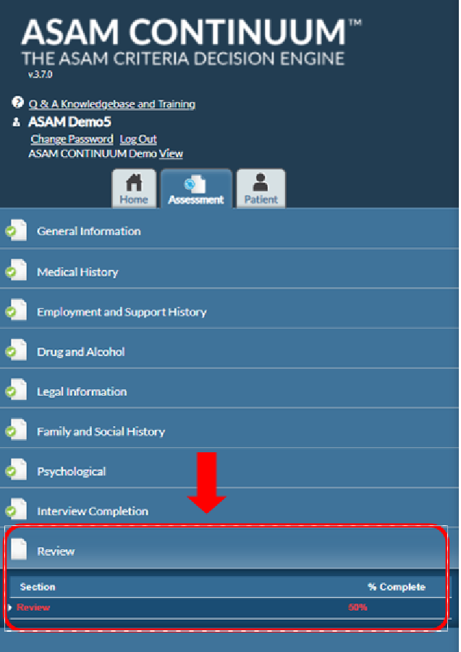

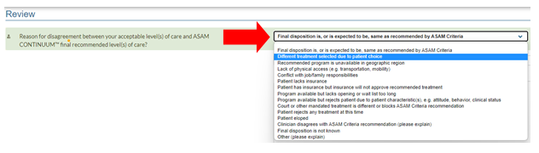

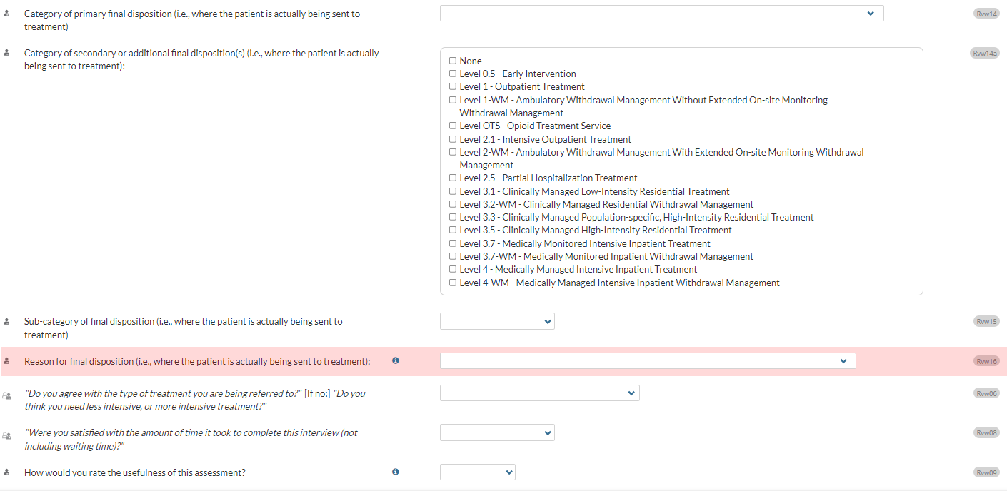

*NEW - How to address when ASAM CONTINUUM® recommends withdrawal management for individuals requesting Medication Assisted Treatment in an outpatient setting?
MSHN has received feedback of the ASAM CONTINUUM® recommending withdrawal management levels of care for individuals requesting medication assisted treatment in outpatient settings. If this occurs, MSHN is recommending providers evaluate the persons needs on an individualized basis to determine the need for withdrawal management and/or outpatient MAT services. If withdrawal management is deemed unnecessary, then the clinician should document this recommendation in the ASAM CONTINUUM® similarly to guidance provided in FAQ Question 19.

Finalizing the Assessment, Signatures, and Reports

How can my supervisor sign-off on my completed CONTINUUM® assessment?
Your agency should create a process which may include printing and signing the assessment and uploading the signature page into the client record in REMI for authorization purposes.

Who will have access to the completed assessment?
Only the provider and the PIHP will have access to completed assessments as they are maintained in the EHR. If a client seeks treatment with another provider, your agency should follow your standard process for releasing and sharing reports with confidential PHI. Data does not populate or “pull-forward” into another providers EHR.

Can I integrate ASAM CONTINUUM® with my agency’s EHR/EMR?
At this time, we are discouraging additional integrations so that we can ensure an efficient statewide implementation, maximizing time and resources. Localized integration may be available at a future date.

What report should I upload to REMI to meet the assessment requirement of authorizations/re-authorizations?
Providers should upload both the Narrative Report and Assessment Summary Report to REMI to support requirements.

Billing and Processing

*NEW- What code do I use for billing a CONTINUUM® Assessment? What code should I use for billing a partial or incomplete CONTINUUM® Assessment?
Complete Assessment:
When you have completed an assessment, you will use the H0001 assessment code. (Note- the previously used H0001-HV was discontinued on 9/30/21.)

Partially Complete Assessment with provisional diagnosis:
When you conduct an assessment and the clinician is able to complete to the point of a provisional diagnosis, then you utilize the H0001 assessment code.

Incomplete Assessment:
If you begin, but do not complete an assessment to the point of determining a provisional diagnosis you will use the H0050 brief screener code. If the consumer returns and the agency is able to complete the assessment, then the agency can bill the H0001 assessment code and must then void the previous claim (H0050).

Assessment Update:
If an assessment update is completed, the provider should utilize an individual therapy session code (i.e. 90832, 90834, 90837, or H0004) instead of the H0001 code. As the ASAM CONTINUUM® has an “update” function which copies forward the previous assessment information, much less time will be needed to update an assessment than completing an initial assessment.

How do I submit for training time reimbursement?
Provider agencies must complete the ASAM Billing form which was originally sent to your contract administrator. Clinicians are eligible for up to 8 hours of time reimbursed at $45/hour. MSHN will cover these initial training costs through 3/31/2022. ASAM training occurring on or after 4/1/2022 will be the provider's responsibility. ASAM Certificate of Completion must be submitted for each clinician listed on the billing form.

*NEW- How should providers bill for an ASAM CONTINUUM® Update?
If an assessment update is completed, the provider should utilize an individual therapy session code (i.e., 90832, 90834, 90837, or H0004) instead of the H0001 code. As the ASAM CONTINUUM® has an “update” function which copies forward the previous assessment information, much less time will be needed to update an assessment than completing an initial assessment. Also, just a note, MDHHS will only support reimbursement of four assessments per year per beneficiary in the SUD provider system. The use of the individual therapy code for assessment updates, will assist with preserving the H0001 encounters for future use, as needed.

*NEW- If more than one session is needed to complete the ASAM CONTINUUM®, how does the provider bill for this occurrence?
If an individual is not able to complete the ASAM CONTINUUM® in one session, then the provider can utilize as many sessions as needed to support the person through the process. Please note, that while multiple sessions may be utilized, the provider can only bill the H0001 code on the date the ASAM CONTINUUM® assessment is completed. To accurately track regional time on assessment, the provider should submit the H0001 code along with the full accumulated time it took to complete the ASAM CONTINUUM® on the date that it was completed in REMI.

Please note, MSHN is reviewing H0001 codes for time on assessment to determine if the assessment reimbursement rates are adequate to support the treatment provider network. From 10-1-2021 thru 3-31-2022, the H0001 code is being reimbursed at $265.50. After 4-1-2022, the rate will be reduced to $160 to reflect the trend of reduced time on assessment.

Other

*NEW- Is there an accreditation crosswalk to compare JACHO and/or CARF standards to ASAM CONTINUUM®?
The CONTINUUM® team conducted analyses and created proposals on how to incorporate the additions of Joint Commission and CARF’s standards, as well as reviewed the algorithmic implications to the tool. ASAM leadership has decided to hold off on implementing the proposals directly into the tool at this time. The analyses showed that to properly implement the elements in a way that would have tangible benefit for providers would require significant updates to the assessment and technical integrations with the EHRs. The crosswalk analysis showed that CONTINUUM® does not have significant overlap with the requirements and would require adding new questions and sections. This would lengthen the assessment and the new components would not directly impact the generation of a level of care recommendation. Additionally, ASAM has started development of the 4th edition of The ASAM Criteria and expect the updated edition will include guidance to directly address many of the Joint Commission and CARF requirements. When that edition is released, they plan to incorporate as many of the elements as possible in the next iteration of CONTINUUM®. MSHN continues to request the crosswalk document for ASAM CONTINUUM® with JACHO and CARF to share with the provider network.

CONTINUUM® Training and Certification

How can I be trained to use ASAM CONTINUUM®?
Going forward, new staff and any untrained staff will first access training for ASAM CONTINUUM® by creating a free account on ASAM eLearning Center and complete the free on-demand training curriculum, the details are below. It is important to note that when a clinician completes the on-demand course they must download their certificate of completion and you will then submit the certificate to your MSHN Treatment Specialist to activate that user’s account and be granted access to CONTINUUM® through REMI.

ASAM CONTINUUM® on-demand training product includes:
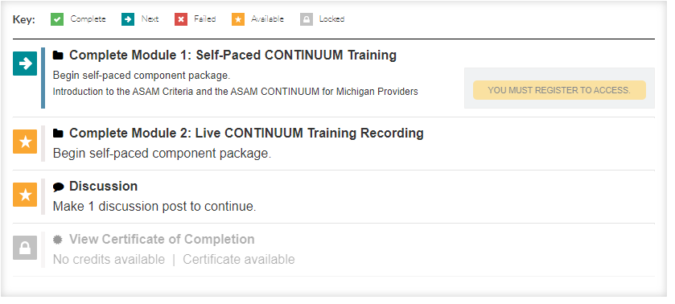
- Self-Paced Module: Introduction to the ASAM Criteria and the ASAM CONTINUUM® for Michigan Providers.
- Recording of a live training that includes:
  - Presentation: ASAM CONTINUUM® Navigation and Best Practices.
  - Demo: Patient interview with the ASAM CONTINUUM®
    - General Information Section
    - Medical Section
    - Psychological Section
    - Interview Completion Section
- Certificate of Completion

The clinicians who have already registered and attended one of the CONTINUUM® cohorts will still have access to their cohort page where they have the option to claim credits for the course they have attended. If those individuals would like to access the on-demand product as well, they are welcome to do so by following the Registration Steps below and skipping step 1. On demand trainees will not receive CE credits.

eLearning Center registration steps:

- If you are signing up for an ASAM course for the first time, you will have to create an account. To create an account, follow this link: https://www.asam.org/login Make sure you scroll to the bottom of the page and review the instructions before you begin creating an account.
  - If you run into any problems, please contact 301.656.3920 or email@asam.org.
  - Please allow time for the customer service team to respond to your inquiry. The customer service team is not always able to respond immediately.
- To register to the ASAM CONTINUUM® course, please follow this link: https://elearning.asam.org/products/asam-CONTINUUM®-course-michigan-on-demand
  - If you run into any problems, consult the FAQ page here: https://elearning.asam.org/faqs or contact 301.656.3920 or education@asam.org.
Please allow time for the customer service team to respond to your inquiry. The customer service team is not always able to respond immediately.
- After creating an account and registering to the course, go to the course page: https://elearning.asam.org/products/asam-CONTINUUM®-course-michigan-on-demand
- Click on the "contents" tab to complete the self-paced module and/or watch the recordings.
  - Please make sure you complete the modules on a laptop or a desktop. If you are using a phone or a tablet, the system may not register your progress and your status will be marked as "incomplete".
- Click on the "resources" tab to view slides and handouts.
- A downloadable certificate of completion will become available after you complete module 1 and module 2.
  - Please note that when completing the modules, you must complete all the sections, interactions and knowledge checks. If you miss something, the system will log your progress as "incomplete”, and you may need to go back into the module and make sure you completed all the required activities.

Technical Support

Who can I contact for support?
For technical support with REMI (i.e., user account information; help text/User Manual) contact: inquiries@midstatehealthnetwork.org

For technical support with the ASAM CONTINUUM® assessment contact: CONTINUUM®Support@FEIsystems.com

